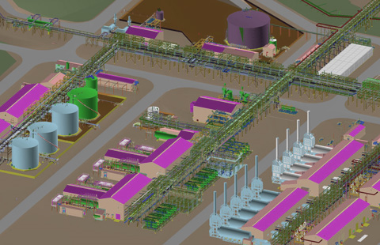

MODEL REVIEW COVENANTS

P&IDs HAVE BEEN THROUGH ALL THE NECESSARY REVIEWS PRIOR TO THE MODEL REVIEWS. THE MODEL REVIEW SHALL NOT BE TREATED AS A FURTHER P&ID REVIEW. ONLY CHANGES AFFECTING DESIGN FUNCTIONS WILL BE CONSIDERED.

THE MODEL REVIEW IS ONE OF THE PRIMARY TOOLS THAT ENSURE THE DESIGN IS IN COMPLIANCE WITH THE CONTRACT COMMITMENTS.

THE MODEL REVIEWS ENSURE THAT SAFETY, ACCESS, OPERABILITY, AND MAINTAINABILITY ARE BUILT IN TO THE NEW FACILITY.

CHANGES WILL RESULT IN REWORK AND MAY LEAD TO INCREASED COSTS AND SCHEDULE DELAYS. CHANGES SHOULD BE LIMITED TO THOSE REASONS AS OUTLINED IN “ ACCEPTABLE REASONS FOR MODEL REVIEW CHANGES”.

ANY CHANGE IS POSSIBLE BUT NOT ALL CHANGES ARE REQUIRED.

LATE CHANGES TO SAVE MONEY USUALLY DO THE OPPOSITE.

A MINOR CHANGE STILL COSTS TIME AND MONEY TO ADDRESS AND IMPLIMENT.

AS A MEMBER OF THE MODEL REVIEW TEAM, IT IS OF MAJOR IMPORTANCE THAT EVERY MEMBER PARTICIPATES WITH THEIR INPUT AND LISTENS TO THE INPUT OF OTHER MEMBERS AND SUPPORTS THE PROCESS OF PRODUCING A WELL DESIGNED AND SUCCESSFUL PROJECT.

